Powerful Kids

On Thursday 20th March while Evans Head and surrounding towns were idling under the lack of power one group was powering ahead.
Five students from the EcoWarriors Student Environment group from Evans River K-12 School, Kelly Wilson, Bradley Rook, Lia Grogan, Erica Bayliss and Tanika Tarrant along with their teacher Mr Jay Mulherin, our Native Nursery supervisor, Ross McFarlane and myself were digging holes and planting Tuckeroo, Banksias and Pandanas trees near the lookout north of the Evans Head Surf Club.
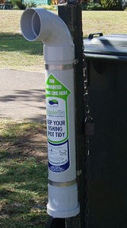
While the rain did prevent our Primary School students from taking part in the tree planting experience, it was great for the new trees. All of the trees planted on the day were from seeds collected locally and propagated by Ross McFarlane, the Nursery supervisor with assistance from students.
The EcoWarriors group are also working on placing four TAngler Bins at popular fishing spots around Evans Head. TAngler Bins are there to encourage people to put their fishing waste such as, lines, hooks and bait bags etc. into them to prevent injuries to birds and sea creatures. The EcoWarriors received a grant for this project from the NSW Environment Trust; they are working with Richmond Valley Council and OceanWatch to select the most suitable locations for the TAngler bins.

